Q1] Write a program to implement following functions in numpy library Array, arange, len, ndim, slicing, copy, view, reshape, concatenate, split

import numpy as np

# Array function

def my_array(arr_list):

return np.array(arr_list)

# arange function

def my_arange(start, stop, step=1):

return np.arange(start, stop, step)

# len function

def my_len(arr):

return len(arr)

# ndim function

def my_ndim(arr):

return arr.ndim

# slicing function

def my_slicing(arr, start=None, stop=None, step=None):

return arr[start:stop:step]

# copy function

def my_copy(arr):

return arr.copy()

# view function

def my_view(arr):

return arr.view()

# reshape function

def my_reshape(arr, shape):

if np.prod(shape) != np.prod(arr.shape):

raise ValueError("Cannot reshape array into the specified shape")

return arr.reshape(shape)

# concatenate function

def my_concatenate(arr1, arr2, axis=0):

return np.concatenate((arr1, arr2), axis=axis)

# split function

def my_split(arr, indices, axis=0):

return np.split(arr, indices, axis=axis)

# Testing the functions

arr1 = my_array([1, 2, 3, 4, 5])

arr2 = my_array([6, 7, 8, 9, 10])

print("Array:")

print(arr1)

print("\narange:")

print(my_arange(0, 10, 2))

print("\nlen:")

print(my_len(arr1))

print("\nndim:")

print(my_ndim(arr1))

print("\nslicing:")

print(my_slicing(arr1, 1, 4, 1))

print("\ncopy:")

arr1_copy = my_copy(arr1)

print(arr1_copy)

print("\nview:")

arr1_view = my_view(arr1)

print(arr1_view)

print("\nreshape:")

arr1_reshaped = my_reshape(arr1, (1, 5)) # Corrected reshape to (1, 5)

print(arr1_reshaped)

print("\nconcatenate:")

print(my_concatenate(arr1, arr2))

print("\nsplit:")

arr_split = my_split(arr1, [2, 4]) # Split into parts of sizes [2, 3]

print(arr_split)

Output:

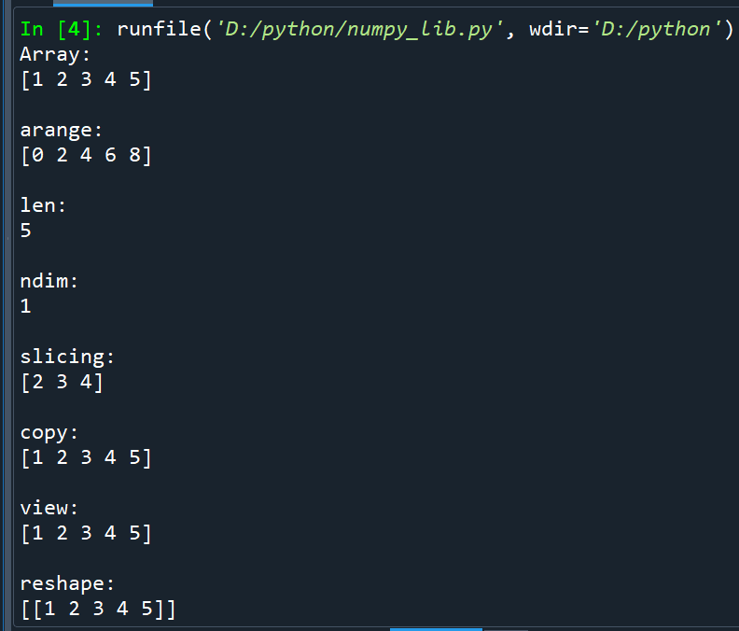

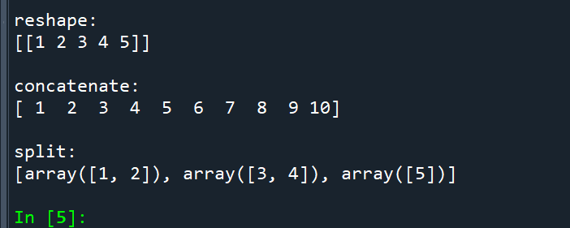

Q2] Write a program to implement following functions in pandas library Dataframe, dropna, fillna, replace specific values

import pandas as pd

import numpy as np

# DataFrame function

def my_dataframe(data_dict):

return pd.DataFrame(data_dict)

# dropna function

def my_dropna(df):

return df.dropna()

# fillna function

def my_fillna(df, value):

return df.fillna(value)

# replace function

def my_replace(df, old_value, new_value):

return df.replace(old_value, new_value)

# Testing the functions

data = {'A': [1, 2, np.nan, 4],

'B': [5, np.nan, 7, 8],

'C': [9, 10, 11, 12]}

df = my_dataframe(data)

print("Original DataFrame:")

print(df)

print("\ndropna:")

print(my_dropna(df))

print("\nfillna:")

print(my_fillna(df, 0))

print("\nreplace:")

print(my_replace(df, 2, 20))

Output:

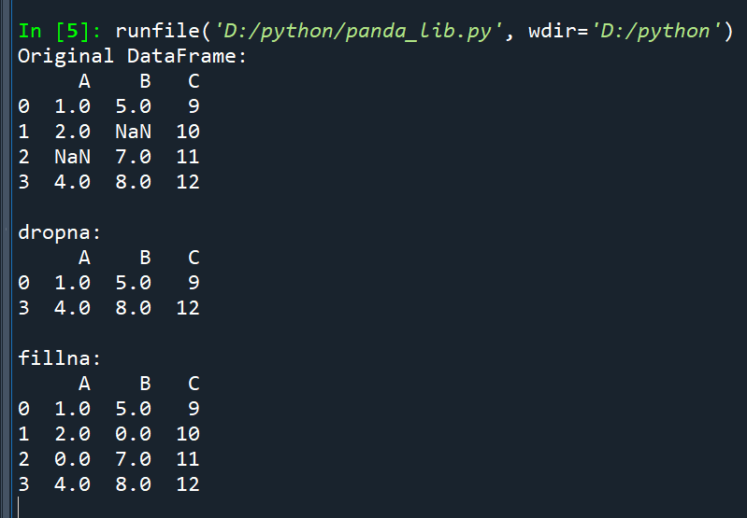

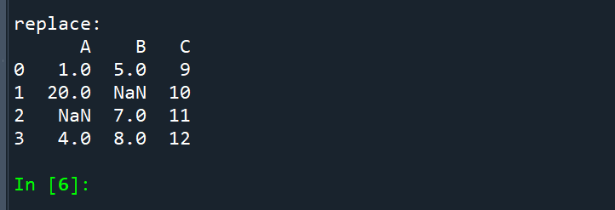

Q3] Write a program to implement following graphs in matplotlib library Line chart, bar chart, scatterplot, pie chart, histogram

import matplotlib.pyplot as plt

import numpy as np

# Create sample data

x = np.arange(1, 11)

y = np.array([2, 4, 6, 8, 10, 12, 14, 16, 18, 20])

# Line Chart

plt.figure(figsize=(8, 4))

plt.plot(x, y, marker='o', linestyle='-', color='b', label='Line Chart')

plt.xlabel('X-axis')

plt.ylabel('Y-axis')

plt.title('Line Chart Example')

plt.legend()

plt.grid(True)

plt.show()

# Bar Chart

categories = ['Category A', 'Category B', 'Category C', 'Category D']

values = [15, 24, 10, 30]

plt.figure(figsize=(8, 4))

plt.bar(categories, values, color='g', alpha=0.7)

plt.xlabel('Categories')

plt.ylabel('Values')

plt.title('Bar Chart Example')

plt.show()

# Scatterplot

x = np.random.rand(50)

y = np.random.rand(50)

plt.figure(figsize=(8, 4))

plt.scatter(x, y, c='r', marker='o', label='Scatterplot')

plt.xlabel('X-axis')

plt.ylabel('Y-axis')

plt.title('Scatterplot Example')

plt.legend()

plt.grid(True)

plt.show()

# Pie Chart

labels = ['Category A', 'Category B', 'Category C', 'Category D']

sizes = [30, 15, 25, 20]

colors = ['gold', 'yellowgreen', 'lightcoral', 'lightskyblue']

plt.figure(figsize=(6, 6))

plt.pie(sizes, labels=labels, colors=colors, autopct='%1.1f%%', startangle=140)

plt.axis('equal')

plt.title('Pie Chart Example')

plt.show()

# Histogram

data = np.random.randn(1000)

plt.figure(figsize=(8, 4))

plt.hist(data, bins=20, color='purple', alpha=0.7)

plt.xlabel('Value')

plt.ylabel('Frequency')

plt.title('Histogram Example')

plt.show()

Output:

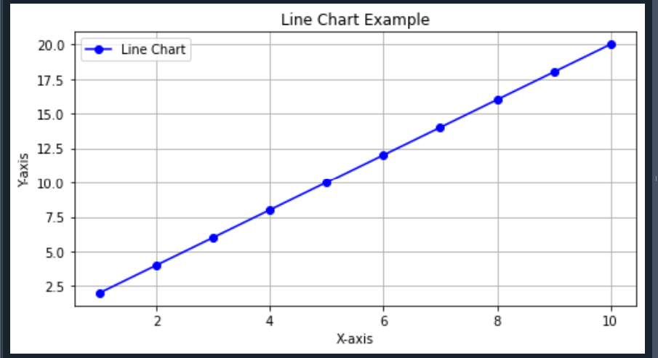

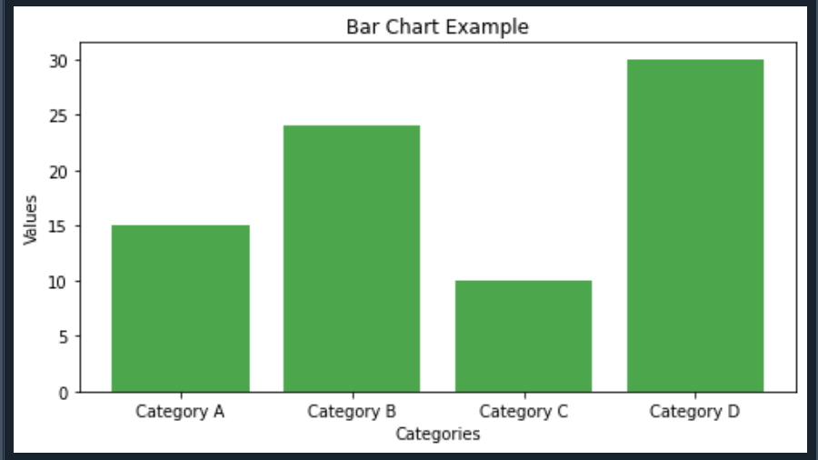

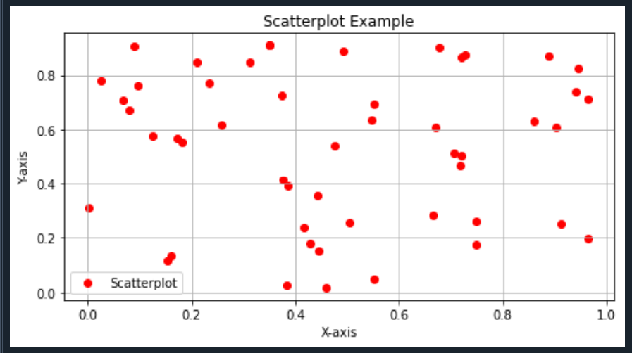

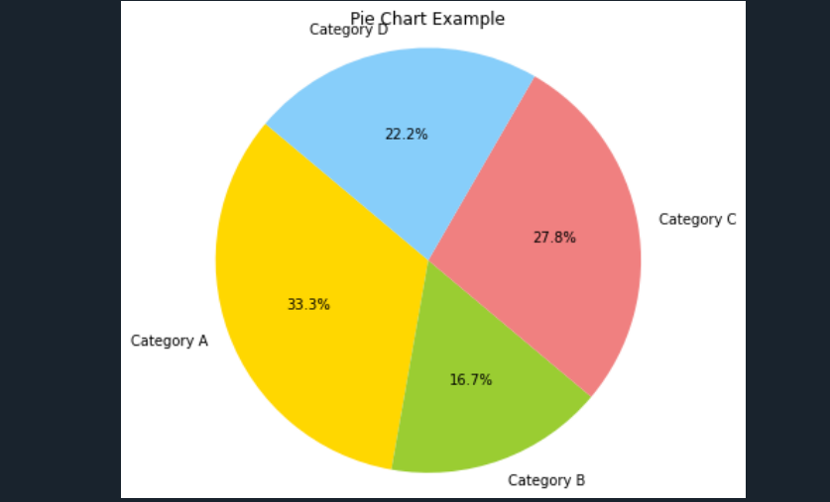

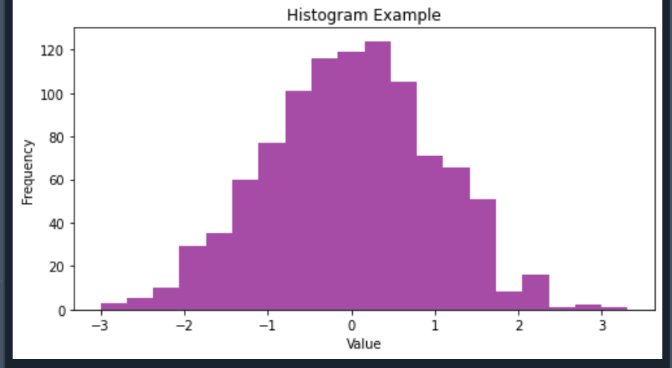

Q4] Write a program to find the correlation matrix

import pandas as pd

# Sample dataset

data = {

'A': [1, 2, 3, 4, 5],

'B': [2, 4, 1, 6, 8],

'C': [5, 7, 3, 8, 9],

'D': [1, 2, 3, 2, 1]

}

# Create a DataFrame

df = pd.DataFrame(data)

# Calculate the correlation matrix

correlation_matrix = df.corr()

# Display the correlation matrix

print("Correlation Matrix:")

print(correlation_matrix)

Output:

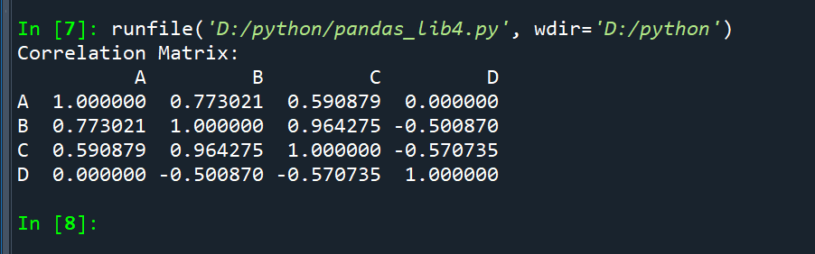

Q5] Create an Android application and understand the Project and file hierarchy.

Activity_main.xml:

<?xml version="1.0" encoding="utf-8"?>  
<LinearLayout xmlns:android="http://schemas.android.com/apk/res/android"  
 xmlns:app="http://schemas.android.com/apk/res-auto"  
 xmlns:tools="http://schemas.android.com/tools"  
 android:layout_width="match_parent"  
 android:layout_height="match_parent"  
 tools:context=".MainActivity">  
 android:layout_width="match_parent"  
 android:layout_height="match_parent"  
 android:orientation="vertical"  
 android:weightSum="100">  
 <TextView  
 android:layout_width="wrap_content"  
 android:layout_height="wrap_content"  
 android:text="Hi Avinash"  
 app:layout_constraintBottom_toBottomOf="parent"  
 app:layout_constraintEnd_toEndOf="parent"  
 app:layout_constraintStart_toStartOf="parent"  
 app:layout_constraintTop_toTopOf="parent"  
 android:textColor="@color/navy"  
 android:textSize="50dp"  
 android:layout_weight="30"  
 />  
 <TextView  
 android:layout_width="wrap_content"  
 android:layout_height="wrap_content"  
 android:text="Have a great Day!"  
 app:layout_constraintBottom_toBottomOf="parent"  
 app:layout_constraintEnd_toEndOf="parent"  
 app:layout_constraintStart_toStartOf="parent"  
 app:layout_constraintTop_toTopOf="parent"  
 android:textColor="@color/maroon"  
 android:textSize="50dp"  
 android:layout_weight="70"  
 android:gravity="center"  
 />  
</LinearLayout>

Mainactivity.java:

package com.example.myapplication  
import androidx.appcompat.app.AppCompatActivity  
import android.os.Bundle  
class MainActivity : AppCompatActivity() {  
 override fun onCreate(savedInstanceState: Bundle?) {  
 super.onCreate(savedInstanceState)  
 setContentView(R.layout.*activity_main*)  
 }  
}

Output:

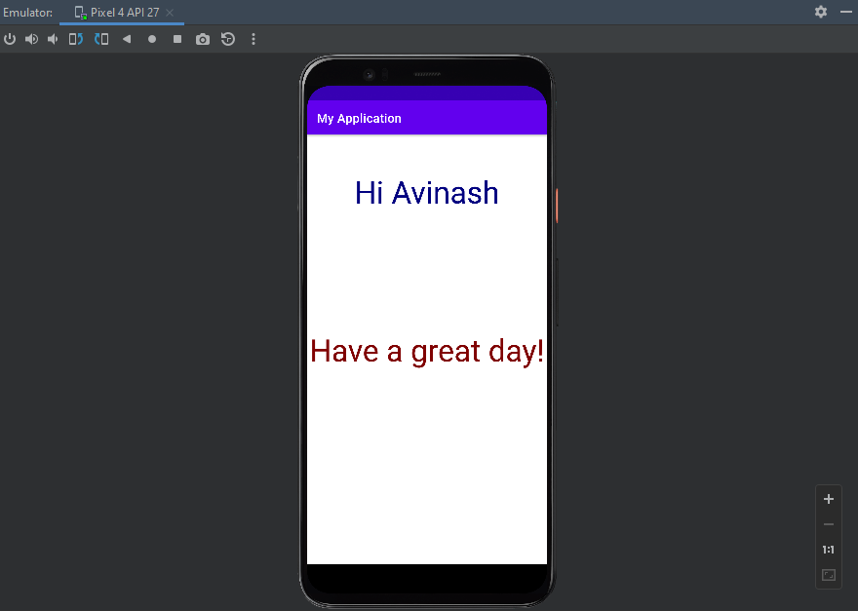

Q6] Develop an Android application that uses GUI components, Font and Colors

Activity_main.xml:

<?xml version="1.0" encoding="utf-8"?>  
<LinearLayout xmlns:android="http://schemas.android.com/apk/res/android"  
 xmlns:app="http://schemas.android.com/apk/res-auto"  
 xmlns:tools="http://schemas.android.com/tools"  
 android:layout_width="match_parent"  
 android:layout_height="match_parent"  
 android:layout_gravity="center"  
 android:orientation="vertical"  
 tools:context=".MainActivity"  
 android:background="@color/RosyBrown"  
 >  
 <TextView  
 android:layout_width="match_parent"  
 android:layout_height="wrap_content"  
 android:layout_gravity="center"  
 android:layout_margin="2dp"  
 android:gravity="center"  
 android:padding="2dp"  
 android:text="Even Odd Program"  
 android:textSize="40dp"  
 android:textColor="@color/FireBrick" />  
 <TextView  
 android:layout_width="match_parent"  
 android:layout_height="wrap_content"  
 android:layout_gravity="center"  
 android:layout_margin="2dp"  
 android:padding="2dp"  
 android:text="Even Or Odd"  
 android:textSize="30dp"  
 android:textColor="@color/LightGrey"  
 />  
 <EditText  
 android:id="@+id/number"  
 android:layout_width="match_parent"  
 android:layout_height="wrap_content"  
 android:layout_margin="10dp"  
 android:background="@color/Pink"  
 android:drawablePadding="10dp"  
 android:hint="Number"  
 android:inputType="number"  
 android:padding="20dp"  
 android:textColorHint="@color/HotPink" />  
 <com.google.android.material.button.MaterialButton  
 android:layout_width="wrap_content"  
 android:layout_height="wrap_content"  
 android:hint="Submit"  
 android:layout_gravity="center"  
 android:backgroundTint="@color/PaleVioletRed"  
 android:textColor="@color/black"  
 android:textSize="30dp"  
 android:id="@+id/submit"  
 android:layout_margin="30dp"  
 android:padding="15dp"/>  
 <TextView  
 android:layout_width="match_parent"  
 android:layout_height="wrap_content"  
 android:id="@+id/resultnum"  
 android:layout_below="@id/submit"  
 android:layout_margin="20dp"  
 android:textSize="30dp"  
 android:textColor="@color/teal_700"/>  
</LinearLayout>

Mainactivity.java:

package com.example.myapplication  
import androidx.appcompat.app.AppCompatActivity  
import android.os.Bundle  
class MainActivity : AppCompatActivity() {  
 override fun onCreate(savedInstanceState: Bundle?) {  
 super.onCreate(savedInstanceState)  
 setContentView(R.layout.*activity_main*)  
 }  
}

Output:

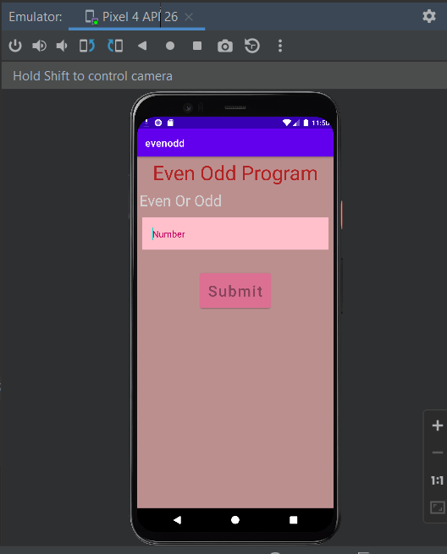

Q7] Develop an Android application that uses Layout Managers

Activity_main.xml:

<?xml version="1.0" encoding="utf-8"?>  
<RelativeLayout  
 xmlns:android="http://schemas.android.com/apk/res/android"  
 xmlns:app="http://schemas.android.com/apk/res-auto"  
 xmlns:tools="http://schemas.android.com/tools"  
 android:layout_width="match_parent"  
 android:layout_height="match_parent"  
 android:padding="16dp"  
 tools:context=".MainActivity">  
 <TextView  
 android:id="@+id/firstNumberLabel"  
 android:layout_width="wrap_content"  
 android:layout_height="wrap_content"  
 android:text="Enter First Number:"  
 android:layout_alignParentStart="true"  
 android:layout_alignParentTop="true"  
 android:layout_marginEnd="8dp"/>  
 <EditText  
 android:id="@+id/firstNumberEditText"  
 android:layout_width="match_parent"  
 android:layout_height="wrap_content"  
 android:layout_toEndOf="@+id/firstNumberLabel"  
 android:layout_alignBaseline="@+id/firstNumberLabel"  
 android:hint="Enter the first number"/>  
 <TextView  
 android:id="@+id/secondNumberLabel"  
 android:layout_width="wrap_content"  
 android:layout_height="wrap_content"  
 android:text="Enter Second Number:"  
 android:layout_below="@+id/firstNumberLabel"  
 android:layout_alignStart="@+id/firstNumberLabel"  
 android:layout_marginTop="16dp"  
 android:layout_marginEnd="8dp"/>  
 <EditText  
 android:id="@+id/secondNumberEditText"  
 android:layout_width="match_parent"  
 android:layout_height="wrap_content"  
 android:layout_toEndOf="@+id/secondNumberLabel"  
 android:layout_alignBaseline="@+id/secondNumberLabel"  
 android:hint="Enter the second number"/>  
 <Button  
 android:id="@+id/multiplyButton"  
 android:layout_width="wrap_content"  
 android:layout_height="wrap_content"  
 android:text="Multiply"  
 android:layout_centerHorizontal="true"  
 android:layout_below="@+id/secondNumberLabel"  
 android:layout_marginTop="16dp"/>  
 <TextView  
 android:id="@+id/resultTextView"  
 android:layout_width="wrap_content"  
 android:layout_height="wrap_content"  
 android:text=""  
 android:layout_centerHorizontal="true"  
 android:layout_below="@+id/multiplyButton"  
 android:layout_marginTop="16dp"/>  
</RelativeLayout>

Mainactivity.java:

package com.example.myapplication  
import androidx.appcompat.app.AppCompatActivity  
import android.os.Bundle  
class MainActivity : AppCompatActivity() {  
 override fun onCreate(savedInstanceState: Bundle?) {  
 super.onCreate(savedInstanceState)  
 setContentView(R.layout.*activity_main*)  
 }  
}

Output:

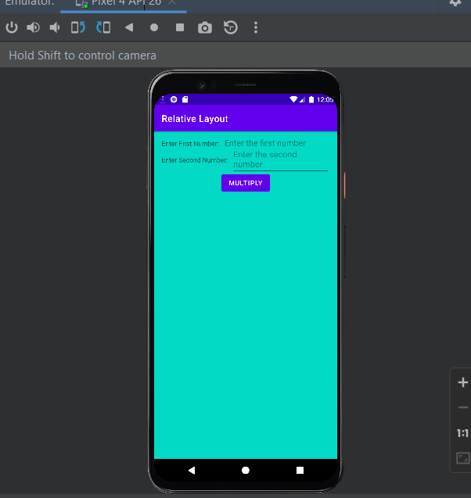

Q8] Develop an Android application that uses Layout Managers Login Form

Activity_main.xml:

<?xml version="1.0" encoding="utf-8"?>  
<LinearLayout  
 xmlns:android="http://schemas.android.com/apk/res/android"  
 android:layout_width="match_parent"  
 android:layout_height="match_parent"  
 android:orientation="vertical"  
 android:padding="16dp">  
 <ImageView  
 android:layout_width="100dp"  
 android:layout_height="100dp"  
 android:src="@drawable/ic_launcher_foreground"  
 android:layout_gravity="center_horizontal"  
 android:layout_marginBottom="16dp"/>  
 <EditText  
 android:id="@+id/et_username"  
 android:layout_width="match_parent"  
 android:layout_height="wrap_content"  
 android:hint="Username"/>  
 <EditText  
 android:id="@+id/et_password"  
 android:layout_width="match_parent"  
 android:layout_height="wrap_content"  
 android:hint="Password"  
 android:inputType="textPassword"/>  
 <Button  
 android:id="@+id/btn_show_toast"  
 android:layout_width="wrap_content"  
 android:layout_height="wrap_content"  
 android:text="Login"  
 android:layout_gravity="center"/>  
</LinearLayout>

Mainactivity.java:

package com.example.loginform;  
  
import android.os.Bundle;  
import android.view.View;  
import android.widget.Button;  
import android.widget.EditText;  
import android.widget.Toast;  
import androidx.appcompat.app.AppCompatActivity;  
  
public class MainActivity extends AppCompatActivity {  
  
 private EditText usernameEditText;  
 private Button showToastButton;  
  
 @Override  
 protected void onCreate(Bundle savedInstanceState) {  
 super.onCreate(savedInstanceState);  
 setContentView(R.layout.*activity_main*);  
  
 // Initialize UI elements  
 usernameEditText = findViewById(R.id.*et_username*);  
 showToastButton = findViewById(R.id.*btn_show_toast*);  
 // Set click listener for the button  
 showToastButton.setOnClickListener(new View.OnClickListener() {  
 @Override  
 public void onClick(View v) {  
 // Get the entered username from the EditText  
 String username = usernameEditText.getText().toString();  
 String toastMessage = "Username: " + username;  
 Toast.*makeText*(MainActivity.this, toastMessage, Toast.*LENGTH_SHORT*).show();  
 }  
 });  
 }  
}

Output:

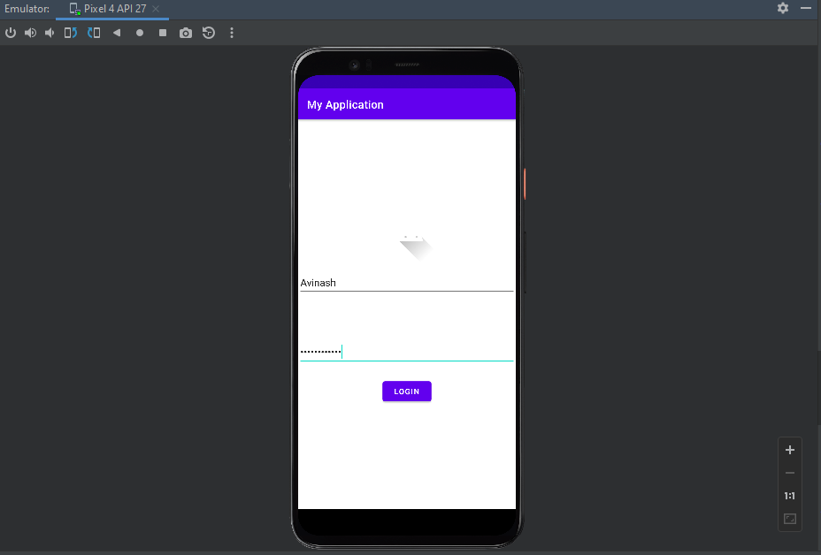

Q9] Develop an Android application that uses Layout Managers and event listeners. Registration form

Activity_main.xml:

<?xml version="1.0" encoding="utf-8"?>  
<LinearLayout xmlns:android="http://schemas.android.com/apk/res/android"  
 xmlns:app="http://schemas.android.com/apk/res-auto"  
 xmlns:tools="http://schemas.android.com/tools"  
 android:layout_width="match_parent"  
 android:layout_height="match_parent"  
 android:background="@drawable/registration"  
 tools:context=".MainActivity"  
 android:orientation="vertical">  
 <TextView  
 android:layout_width="match_parent"  
 android:layout_height="wrap_content"  
 android:id="@+id/register"  
 android:text="Registration Form"  
 android:textSize="40dp"  
 android:gravity="center"  
 android:layout_margin="20dp"  
 android:textColor="@color/white"  
 app:layout_constraintBottom_toBottomOf="parent"  
 app:layout_constraintEnd_toEndOf="parent"  
 app:layout_constraintStart_toStartOf="parent"  
 app:layout_constraintTop_toTopOf="parent" />  
 <EditText  
 android:layout_width="match_parent"  
 android:layout_height="wrap_content"  
 android:id="@+id/studentname"  
 android:layout_below="@id/register"  
 android:background="#30ffffff"  
 android:hint="Student Name"  
 android:textColorHint="@color/white"  
 android:textColor="@color/white"  
 android:layout_margin="10dp"  
 android:padding="20dp"  
 android:drawableLeft="@drawable/ic_baseline_person_24"  
 android:drawablePadding="10dp"  
 android:inputType="textPersonName"/>/>  
 <EditText  
 android:layout_width="match_parent"  
 android:layout_height="wrap_content"  
 android:id="@+id/studentemail"  
 android:layout_below="@id/studentname"  
 android:background="#30ffffff"  
 android:hint="Student Email"  
 android:textColorHint="@color/white"  
 android:textColor="@color/white"  
 android:layout_margin="10dp"  
 android:padding="20dp"  
 android:drawableLeft="@drawable/ic_baseline_alternate_email_24"  
 android:drawablePadding="10dp"  
 android:inputType="textEmailAddress"/>/>  
 <EditText  
 android:layout_width="match_parent"  
 android:layout_height="wrap_content"  
 android:id="@+id/number"  
 android:layout_below="@id/studentemail"  
 android:background="#30ffffff"  
 android:hint="Mobile Number"  
 android:textColorHint="@color/white"  
 android:textColor="@color/white"  
 android:layout_margin="10dp"  
 android:padding="20dp"  
 android:drawableLeft="@drawable/ic_baseline_local_phone_24"  
 android:drawablePadding="10dp"  
 android:inputType="text|phone"/>  
 <EditText  
 android:layout_width="match_parent"  
 android:layout_height="wrap_content"  
 android:id="@+id/studentpassword"  
 android:layout_below="@id/number"  
 android:background="#30ffffff"  
 android:hint="Password"  
 android:textColorHint="@color/white"  
 android:textColor="@color/white"  
 android:layout_margin="10dp"  
 android:padding="20dp"  
 android:drawableLeft="@drawable/ic_baseline_info_24"  
 android:drawablePadding="10dp"  
 android:inputType="textPassword"/>  
 <EditText  
 android:layout_width="match_parent"  
 android:layout_height="wrap_content"  
 android:id="@+id/repassword"  
 android:layout_below="@id/studentpassword"  
 android:background="#30ffffff"  
 android:hint="Confirm Password"  
 android:textColorHint="@color/white"  
 android:textColor="@color/white"  
 android:layout_margin="10dp"  
 android:padding="20dp"  
 android:drawableLeft="@drawable/ic_baseline_info_24"  
 android:drawablePadding="10dp"  
 android:inputType="textPassword"/>  
 <com.google.android.material.button.MaterialButton  
 android:id="@+id/registerbtn"  
 android:layout_width="wrap_content"  
 android:layout_height="wrap_content"  
 android:layout_below="@id/repassword"  
 android:layout_centerHorizontal="true"  
 android:layout_margin="20dp"  
 android:backgroundTint="@color/design_default_color_background"  
 android:text="Register"  
 android:textColor="@color/black"  
 android:layout_gravity="center"/>  
</LinearLayout>

Mainactivity.java:

package com.example.registrationform;  
  
import androidx.appcompat.app.AppCompatActivity;  
  
import android.content.Intent;  
import android.os.Bundle;  
import android.text.Editable;  
import android.view.View;  
import android.widget.EditText;  
import android.widget.Toast;  
  
import com.google.android.material.button.MaterialButton;  
  
public class MainActivity extends AppCompatActivity {  
  
 @Override  
 protected void onCreate(Bundle savedInstanceState) {  
 super.onCreate(savedInstanceState);  
 setContentView(R.layout.*activity_main*);  
  
 EditText studentname= (EditText) findViewById(R.id.*studentname*);  
 MaterialButton register= (MaterialButton) findViewById(R.id.*registerbtn*);  
 register.setOnClickListener(new View.OnClickListener() {  
 @Override  
 public void onClick(View view) {  
 String studentname1=studentname.getText().toString();  
 Toast.*makeText*(MainActivity.this,"Registered Student "+studentname1,Toast.*LENGTH_SHORT*).show();

}  
 });  
 }  
}

Output:

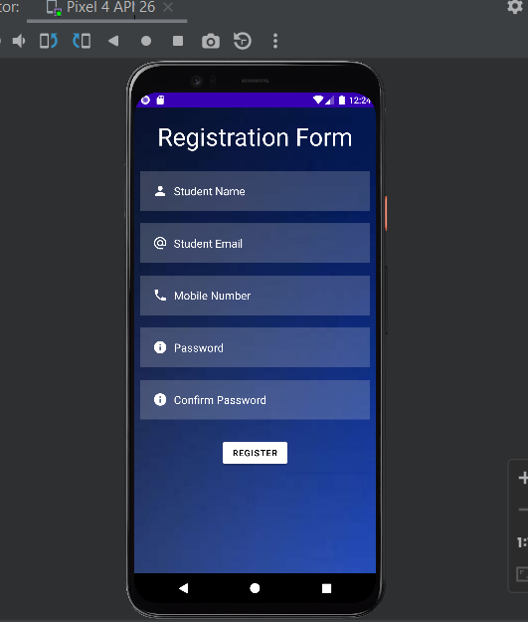

Q10] Develop an Android application that uses Layout Managers and event listeners. Subscription form and Login form

Activity_main.xml:  
<LinearLayout  
 xmlns:android="http://schemas.android.com/apk/res/android"  
 android:layout_width="match_parent"  
 android:layout_height="match_parent"  
 android:orientation="vertical"  
 android:padding="16dp">  
 <EditText  
 android:id="@+id/email"  
 android:layout_width="match_parent"  
 android:layout_height="wrap_content"  
 android:hint="Email"/>  
 <EditText  
 android:id="@+id/et_password"  
 android:layout_width="match_parent"  
 android:layout_height="wrap_content"  
 android:hint="Password"  
 android:inputType="textPassword"/>  
 <Button  
 android:id="@+id/btn_subscribe"  
 android:layout_width="match_parent"  
 android:layout_height="wrap_content"  
 android:text="Subscribe"/>  
</LinearLayout>

Mainactivity.java:

package com.example.subscriptionform;  
import android.os.Bundle;  
import android.view.View;  
import android.widget.Button;  
import android.widget.EditText;  
import android.widget.Toast;  
import androidx.appcompat.app.AppCompatActivity;  
public class MainActivity extends AppCompatActivity {  
 private EditText emailEditText;  
 private EditText passwordEditText;  
 private Button subscribeButton;  
 @Override  
 protected void onCreate(Bundle savedInstanceState) {  
 super.onCreate(savedInstanceState);  
 setContentView(R.layout.*activity_main*);  
 emailEditText = findViewById(R.id.*email*);  
 passwordEditText = findViewById(R.id.*et_password*);  
 subscribeButton = findViewById(R.id.*btn_subscribe*);  
 subscribeButton.setOnClickListener(new View.OnClickListener() {  
 @Override  
 public void onClick(View v) {  
 String email = emailEditText.getText().toString();  
 String password = passwordEditText.getText().toString();  
 // You can add logic here to handle the subscription process  
 Toast.*makeText*(MainActivity.this, "Subscription successful", Toast.*LENGTH_SHORT*).show();  
 }  
 });  
 }  
}

Output:

